**Network Architecture**

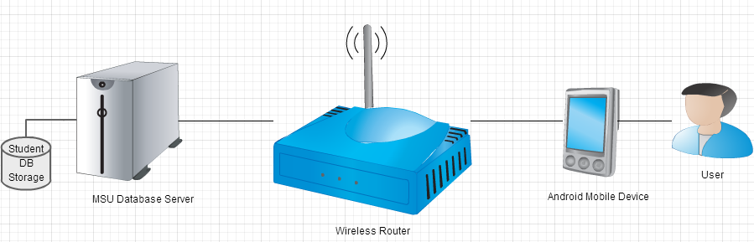

Figure 1. Network Architecture Diagram

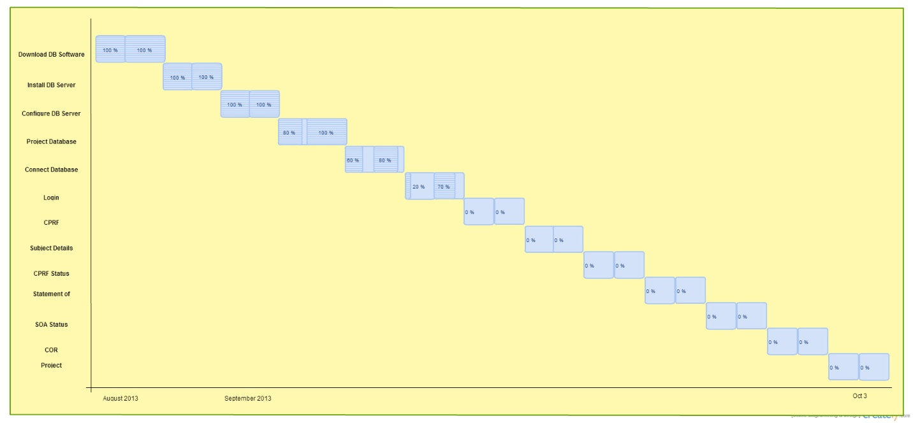

Figure 2: Gantt Chart

Figure 3: Burn Down Chart